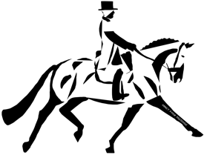

Site Rules.
By signing I agree myself, and those accompanying me will follow the site rules below:
- Please respect that these are exceptionally beautiful facilities, and someone’s home, excessive noise, poor behaviour, and littering will not be tolerated at any time.
- All litter must be collected and disposed of appropriately.
- Please don’t let your horse wee on the indoor arena surface.
- You must pick your horse’s feet out before you leave the stable and before enter/leave the arena.
- Please do not wander around with your horse aimlessly, there are areas to wash off, warm up etc. Unless you are working your horse, please put them in your box/trailer to keep them safe and protect property.
- Horses must not be tied to vehicles, as they would get lost in the vast parkland if they pulled away.
- Dogs must be kept on a lead at all times, any poo must be picked up and disposed of appropriately.
- Horses with cough or nasal discharge will not be allowed onto the premises.
- You may not attend a clinic/class/arena hire if you are/have been within 5 miles of a yard/venue with a contagious disease during the last 21 days.
- While mounted, you must wear a protective hat, which complies with the current safety standards at all times.
- Body protectors are recommended for pole work and jumping but are not compulsory.
- If you bring your own instructor, please make sure they have adequate insurance cover. Inadequate insurance or failure to supply evidence on request will forfeit your booking and payment.
- For stabling, you will need to provide your own bedding and mucking out equipment, feed buckets, hay nets etc.
- For stabling, you will need to bring your own hay, in a format where is will not blow all over the yard.

PRINT NAME:.……………………………………………………………………………………………………………..
SIGNATURE:……………….………………………………………………………………………………………………..
DATE:……………………………………………………………………………………………………………………………

